The process of inferring insights from sample data is called inferential statistics

Infer mean do some conclusions on something based on some evidence
- You observe a sample
- Quantify uncertainty using probability
ML
- Model generalization
  - we train the models on a sample data / training data
  - infer how well model will perform on unseen data / test or real-data
  - tools cross validation and confidence intervals
- feature selection and hypothesis testing
  - understand if a feature truly impacts the target variable?
  - Use p-values, tests or ANOVA to infer significance
  - Helps reduce overfitting

Probability
It is measure of how likely an event is to occur. It quantifies uncertainty using a value between 0 & 1
- 0 means – event is impossible
- 1 means – event is certain
- Values in between reflect varying degrees of likelihood

P( E) = no.of favorable outcomes / total no.of possible outcomes
Ex
If a six sided die is rolled, the probability of getting a “4” is 1/6

ML
ML, AI systems operate in uncertain, noisy and incomplete environments. Probability provides tools to reason, learn and make decisions despite that uncertainity

Role | Probability helps
Model uncertainty | ML models use probability distributions to represent randomness in data
Prediction confidence | Outputs are probabilistic ex: 80% chance that this image contains a cat
Learning from data | Algorithms like naïve bayes and logistic regression are built on top of probability logic
Decision making | AI systems use probabilities to weigh risks and choose optimal actions
Sampling and generalization | Probability allow models trained on samples to generalize to larger population

Examples

Spam detection
- Email is a 95% probability of being spam
  - Probability helping here to decide whether to block it
- Self driving car
  - 70% chance it’s a pedestrian
    - Car breakes to avoid risk, even if not sure 100%
- Health care
  - AI predicts probability of diabetes = 80%
    - Helps doctors make informed decisions

ML and AI deal with uncertainty
Data we collect is often noisy, incomplete or unpredictable
Probability gives us a mathematical framework to handle uncertainty and making useful predictions
Without probability, ML models would either be overconfident / unable to generalize

Addition rule of probability
Used when considering the chance of either event A or event B happening.

Formula
P(AUB) = P(A) + P(B) – P(A intersection B)

Example
A customer ordered something from amazon
Probability its delivered late = 0.1
Probability the product is defective = 0.05
Probability of both happening together = 0.02
So, probability that customer faces either a late delivery or a defect = 0.1 + 0.05 – 0.02 = 0.13 (13%)

Independent events

Two events are independent if one does not affect the other.
Ex:
Tossing a coin and rolling a die
- The outcome of the coin toss doesn’t affect the roll.
ML
- Netflix whether a Netflix user in india renews their subscription is independent of whether a user in US does

Random variables
A random variable (X) maps outcomes of an experiment to numerical values
Ex toss a coin
- X =1 if heads, 0 if tails
ML business scenario
Amazon Quality control dept X = number of defective items found in a sample of 20
Key point random variables turn qualitative experiments into measurable data

Probability distributions
It describe how probabilities are spread over different values of a random variable
Ex
- If you roll a die, probability of each outcome = 1/6
ML
Customer service calls per hour might follow a poisson distribution
Product defects might follow a binomial distribution

Expected value
Expected value is the long run average outcome / expected value can come from if an experiment or decision were repeated many times
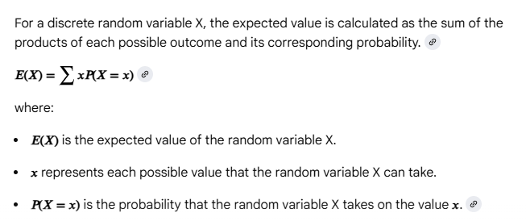
x = value of each outcome
P(x) probability of the outcome
Summation – add this for all possible outcomes

Ex
Lottery ticket
Ticket costs = $2
Prize = $100
Probability of winning = 0.01 (1%)
Probability of losing = 0.99 (99%)

Possible outcomes
- Win gain = $100 - $2 = $98
- Lose gain = $0 - $2 = -$2
X1 = 98, P(X1) = 0.01
X2 = -2, P(X2) = 0.99

Substitute in formula
E(X) = x1.P(x1) + x2.P(X2) = (98 X 0.01) + (-2 X 0.99) = 0.98 – 1.98 = -1.0
Interpretation
Expected value -$1.0 per ticket
If you keep continue playing lottery for many times , every time you may lose $1 per ticket
Business use expected value to assess risks in investments, product launches
Key point
Expected value tell us not what will happen in a single trial, but what will happen on average in the long run

Inferential stats allows us to generalize from samples to populations
Require knowledge of probability, random variable, distributions and expected value
Inference gives estimates with uncertainty, not the exact answer

Bayes Theorem – Naïve Bayes Classifier
This helps us update the probability of a hypothesis given new evidence

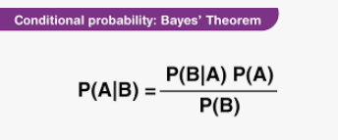

- P(A|B):
This is what you want to calculate. It's the probability of event A happening given that event B has already occurred.
- P(B|A):
This is the probability of event B happening given that event A has already occurred. It's often easier to determine than P(A|B) directly.
- P(A):
This is the prior probability of event A. It's your initial belief about the probability of A before you consider any evidence B.
- P(B):
This is the probability of event B happening. It acts as a normalizing constant, ensuring the probabilities in the formula sum to 1.
- In simpler terms:
Bayes' Theorem allows you to update your initial belief about something (P(A)) with new evidence (B) to arrive at a more informed belief (P(A|B)).

ML
Naïve bayes classifier uses bayes theorem to predict class probabilities
Assumes features are independent
Ex
Email filtering
- Spam or not word “offer”
- If probability is high, classify as spam

Probability allows us to classify text, documents , images efficiently

Logistic regression

This is a classification algorithm
It’s used to predict the probability that a given input belongs to a particular class (spam vs not spam, disease vs no disease)

Logistic regression models the condition probability distribution of the target variables Y given input features X, using the logistic (sigmoid) function

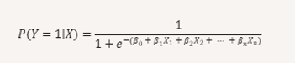

Probability between 0 and 1

- The output is not a hard label, but a probability score
- We can set a threshold to convert into a class label

ML
Predicts probabilities instead of exact labels
Threshold decides classification

Conditional probability hidden markov models

Conditional prob = probability of event A given event B

P(A/B) = P(A intersection B) / P(B)

ML
HMMs use conditional probabilities to model sequence

Ex
Speech recognition given a previous word, what’s the probability of next word?

Probability enables models to predict sequences under uncertainty (language, stock markets…)

Expected Value

EV = long run average reward/value

ML
Reinforcement learning agents choose actions to maximize expected reward
Ex
Self driving car chooses whether to stop or accelerate based on EV
Probability ensures agents learn the best long term strategy under uncertainity

Probability distributions – Bayesian networks

Joint probability distributions represent relationships between variables

ML
Bayesian networks represent dependencies between features using graph

Ex
Medical diagnosis system

Sampling and likelihood deep learning
Likelihood probability of data given parameters
ML
Neural networks minimize a probabilistic loss function (ex: cross entropy)
Cross entropy measures the distance between predicted probabilities and actual outcomes
Ex:
Image recognition, cat: 0.92, Dob: 0.05 , Horse: 0.03
Probability helps neural network express predictions as confidence scores

Probability concept | ML/AI application | Example
Bayes theorem | Naïve Bayes | Spam filtering
Probability distributions | Logistic regression | Customer churn prediction
Conditional probability | HMMs, sequence models | Speech recognition
Expected value | Reinforcement learning | Self driving cars,
Joint probability | Bayesian networks | Medical diagnosis
Likelihood and entropy | Deep learning | Image classification

Discrete probability distribution

A DPD assigns probabilities to distinct outcomes of a random variable
Each prob must be between 0 and 1, sum of prob must equal to 1

Three imp types of discrete distributions
- Bernoulli distribution – binary outcomes (success or failure)
- Binomial distribution – number of successes in n trials
- Poisson distribution – number of events in a fixed interval (ex no.of support tickets per day, calls per hour)

Naïve bayes classifiers (word counts)
Recommendation systems (clicks, ratings)
Fraud detection (transaction counts)
DPD exercise
A survey has been taken how many cups of coffee do you drink per day?
Responses
0 cups: 10%
1 cup: 30%
2 cups: 40%
3 cups: 15%
4+ cups: 5%

What’s the expected value ?
Whats the most probable outcome?

Cups per day | Probability
0 | 0.10
1 | 0.30
2 | 0.40
3 | 0.15
4+ | 0.05

Expected value (Mean)
E(X) is average no.of cups consumed per person
E(X) = sigma x.P(x) = (0x0.10) + (1x0.3) + (2x0.4) + (3x0.15) + (4x0.05) = <<VALUE>>
Interpret on average, people drink <<VALUE>> cups of coffee per day
Most probable outcome (Mode)
The mode is the value of X with highest probability
P(X=2) = 0.40 highest among all
Most common response 2 cups per day

DPD helps us quantify uncertainty, make predictions and to design smarter tools

Binomial probability distribution
BPD models the no.of successes in fixed no.of independent trails
- Discrete distribution
- Fixed no.of trials n
- Each trail has two outcomes – success or failure
- Constant probability p
- Random variable x = no.of successes

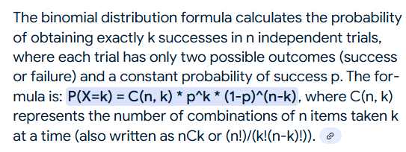

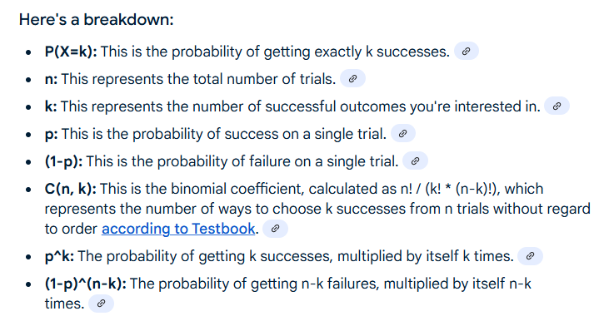

Ex
You flip a fair coin 5 times – what’s the probability of getting exactly 3 heads?
n=5, p=0.5,X=3
P(X=3) = {5! /( 3! * (5-3)!)} * {(0.5) power of 3} * {(1-0.5) power of (5-3)} = <<VALUE>>

Use cases
Defective items in a batch
Clinical trails (no.of patients responding to a treatment)

Uniform Probability distribution
UPD assigns equal probability to all outcomes in a given range

- Discrete or continuous
- All outcomes are equally likely
- For discrete each value has probability of 1/n
- For continuous probability density is constant over interval

Ex
Descrete
Roll a 6-sided die. What’s the probability of getting a 4?
Outcomes = {1,2,3,4,5,6}
Each has a probability 1/6

Continuous
Randomly pick a number between 0 and 10. What’s the probability it falls in between 2 and 5?
Total range = 10
Interval = 3
Probability = 3/10 = 0.3

Use cases
Random sampling
Simulations

Feature | Binomial | Uniform
Type | Discrete | Discrete or continuous
Shape | Bell shaped | Flat (equal probabilities)
Parameters | n,p | Range(discrete or interval)
Outcomes | Vary based on success count | All outcomes equally likely
Ex | Coin tosses, defect rates | Die rolls, random number generation
ML | Success / failure modeling | simulations
 | How many times does something happen | Everything is equally likely

Discrete vs continuous

 | D | C
Values | Countable (0,1,2) | Infinite within an interval
Probability | Assigned to exact values | Assigned to intervals
Ex | Number of blue balls drawn from a basket | Height of a person
 | How many emails did you get today? 0,1,2,3.. | How long did you sleep last night? 6.5 hrs, 7.25 hours

Probability in continuous distributions – we mention the probability of a value falling within a range
P(X=x) = 0 but P(a<= X <=b) > 0

- Continuous variables take on infinite values within a range
- Probability measured over intervals, not on exact points

Ex
An org tracks employee commute times
Probability of exactly 35 mins = 0
Probability of between 35 and 40 mins = 0.2

Interpret
What’s the chance of falling in a range?

Continuous variable require interval based probability
Probability of an exact value = 0

Poisson distribution
- Modeling rare events over the time (ML and AI context) - anomaly detection, NLP etc.,

PD models the probability of observing certain no.of events in a fixed interval of time
- Assumption the events occur independently

Formula
P(X=k)
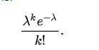
X = no.of events
T=average rate (mean no,of events per interval)
K=actual no.of events
e=2.718 (Euler’s number)

poisson curve
PC is discrete probability distribution shaped like a skewed bell.
For small T, it’s a skewed right (rare events)
As T increases, it becomes more symmetric and resembles a normal distribution
Poisson curves (distributions)
- Skewness: Poisson distributions are positively skewed, meaning they have a longer tail to the right side. This skewness is more pronounced when the mean (λ) is small.
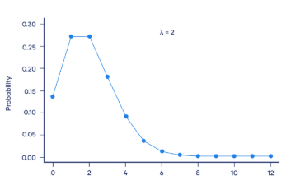

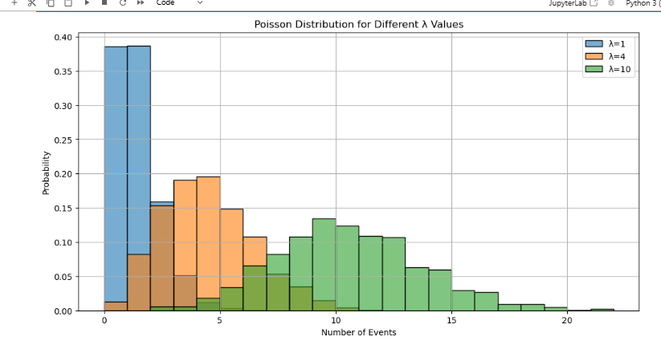

Bell curves (normal distributions)
- Symmetry: Bell curves are perfectly symmetrical around their mean.
- Mean, median, and mode: The mean, median, and mode are all equal and located at the center of the distribution, which is also the peak of the curve.

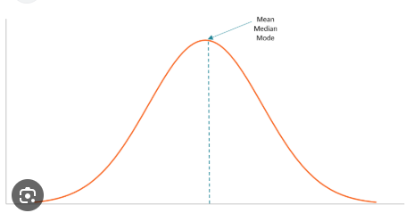

ML
Anomaly detection
- Fraud, server errors
- T=2 error/hr, and observed 10, it’s a red flag

NLP modeling word occurrences in documents
- Rare words follow a poisson like distribution

Predicting arrival rates in systems i.e customer support, API requests
Modeling patient arrivals in emergency rooms

- Example
A chatbot receives an average of 3 queries per minute. What’s the probability it gets exactly 5 queries in a minute?
X = no.of events
T=3
K=5
e=2.718 (Euler’s number)
3 power of 5 x e power of -3 / 5! = <<VALUE>> lets say we got a value of 0.21007
Interpret a 20% chance of receiving exactly 5 queries in a minute

Geometric distribution
- For modeling waiting times until the first success in a sequence of trials – reinforcement learning, simulation
Formula
First success occurs on the k th trial, assuming each trial is independent and has constant probability of success p

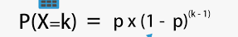

X = n.of trials until first success
P=probability of success on each trial
K=trial number where first success occurs

Geometric distribution curve
The curve is monotonically decreasing
Highest probability is at k=1 (success on first trial)
Long tail for small p: rare successes take many trials

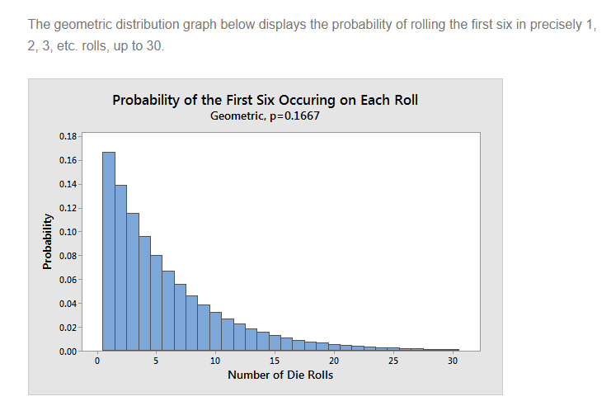

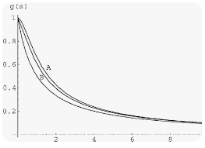

ML
Reinforcement learning – modeling how many steps an agent takes before achieving a reward

Simulation – estimating how long it takes to hit a target condition

Ex
Lets say a spam filter has a 10% chance of correctly flagging a spam email. What’s the probability it flags the first spam on 3rd email?

X = n.of trials until first success
P=probability of success on each trial
K=trial number where first success occurs
P(X=3) = (1-0.1)^2 x 0.1 = 0.81 x 0.1 = 0.081
Interpret there is a 8.1% chance the first spam is flagged on the 3rd email.

Central Limit Theorem

Insights
~ 70 / 3000 / …
300,000 ….entire indian population…
Here the data is increasing for analysis..

Average – no.of times people in urban india visited malls last year?
Really its time consuming process –

How to reduce the time , money on finding such numbers?

Population/sample | Term | Notation | Formula
Population  (x1,x2…..xn) | Population size | N | Elements in the population
 | Population mean |  | 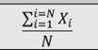
 | Population variance | 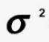 | 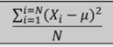
Sample  (x1,x2…..xn) | Sample size | n | Elements in the sample
 | Sample mean | -  X | 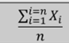
 | Sample variance | S^2 | 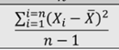

Two imp properties for a sampling distribution of the mean
- Sampling distribution’s mean () = population mean ()
- Sampling distribution’s standard deviation (Standard error) = 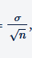
Where the population’s standard deviation and n is is the sample size

CLT
If we keep taking samples and calculate their averages, those averages will form a bell shaped curve (normal distribution) even if original data is not normal.

Try this out
https://onlinestatbook.com/stat_sim/sampling_dist/index.html

Ex
- Imagine rolling a die
- Numbers {1,2,3,4,5,6} are not normally distributed (they are uniform)
- If the die is rolled 30 times and take the average
  - Repeat the step many times
- The graph of those averages will look like a normal distribution

ML
We often measure performance
- Accuracy changes if we test on different data
- But if we take many averages of accuracy they follow a normal distribution (CLT)
  - This allows us to compare models without any bias and make predictions about performance

Confidence Interval
We may be sure that real average is between two numbers
Ex measured 50 bolts, average length = 5.1 cm
- CI = (5.0, 5.2)
- We are 95% sure that the real average bolt length is between 5.0 and 5.2

CLT
If you take sufficiently large random samples from any population, the distribution of the sample means will approximate a normal distribution, regardless of the data original shape.

Standard Error
SE tells – how much a sample mean is likely to vary from sample to sample.

Ex
Estimate average weight of apples in a large bucket. Large bucket >=10,000 apples

Sample# | Apple weights (grams) | Sample mean
1 | 150,160,155,145,152 | 152.4
2 | 158,162,149,151,155 | 155
3 | 148,150,153,149,151 | 150.2
4 | 160,165,158,162,159 | 160.8
5 | 155,157,154,156,158 | 156

From above – each sample gives a slightly different mean. That variation is what standard error captures
Lets say standard deviation of apple weighs from that large volume is 10 grams, above sample size is 5 apples

SE = SD/square root of n = 10 / square root of 5 =
= 4.47

Interpret
If samplings done on 5 apples, sample mean will typically vary by about +-4.47 grams from the real value / true of population mean

Smaller SE -> more precise estimate of the population mean
Larger sample size smaller SE

CI
[150,160, 155,145,152] – data points
Sample mean X bar = 152.4
Sample standard deviation ~
SD = 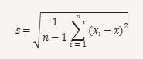
Find deviations from the mean = 150-152.4 = <<value1>>
160-152.4 = <<value2>>
155-152.4=<<value3>>
….on all data points
Square each deviation a1= value1^2, a2=value2^2…..
Sum of squared deviations a1+a2+a3+a4+a5 = <<value_a>>
n-1 5-1=4
<<value_a>>/4
S = square root of <<value_a>> / 4 = 5.59

SE = SD/square root of n = 5.59 / square root of 5 ~ 2.61
It mean sampled 5 apples, sample mean may vary by +- 2.61 grams

Confidence Level tells us how sure we want to be that our interval contains the true population mean
Confidence level | z-score
90% | 1.645
95% | 1.96
99% | 2.576

Reference z table
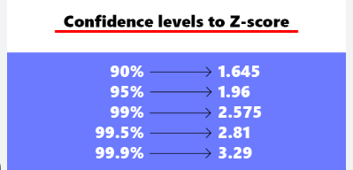
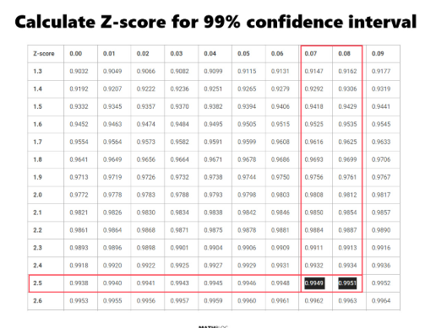

Confidence interval
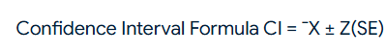
= 152.4 + (1.96 x 2.61) , 152.4 - (1.96 x 2.61)
= 147.28 , 157.51

We are 95% confident that true average weight of apples in the bucket is between 147.28 and 157.51 g

CLT justifies using normal distribution for sample means normal distribution
SE quantifies variability in sample means measures spread
CI uses SE and CLT to estimate population parameters with lower bound and upper bound range

Hypothesis Testing
- Types of hypotheses
- Types of tests
- Decision making criteria
- Critical value and p-value

Inferential stats estimate unknown population parameters using sample data
Hypothesis test validate a known or assumed parameter using sample evidence

Ex
Inferential stats We don’t know the average screen time of users, so we take a sample 100 users and estimate it
Hypothesis test you believe the average screen time is 120 mins. You sample 100 users to test if your belief is true.
Hypothesis test starts with two claims
- Null hypothesis (Ho) : the default assumption ( from above ex: the average is 120 mins)
- Alternate hypothesis (H1): the challenger (from above ex: the average is not 120 mins)
Rule of thumb
Ho uses: = , <=, >=
H1 uses:  , >, <

Types of tests
Two-failed testing for any difference H1 symbol
Left-failed testing if value is lower H1 symbol <
Right-failed testing if value is higher H1 symbol >

Critical value method
You believe that average commute time is 36 min. You sample 100 employees and get a mean of 38. If 38 falls outside the critical range, you reject Ho
- Choose a significance level (alpha) like 5%
- Find z critical value from Z-table
- Calculate upper and lower critical values
- Compare sample mean to these values

p-value method
- Calculate z-score for the sample mean
- Use z-table to find p-value
- Compare p-value to alpha (ex: 0.05)
Rule
- If p-value < alpha reject Ho
- If p-value >= alpha fail to reject Ho

Hypothesis testing helps validate assumptions using sample data
Two methods CVM and p-value
Errors are possible – we quantify them using alpha and beta

